Industrial Training Report
On
Climate Prediction System using Random Forest and FastAPI
In a partial fulfilment for the award of the degree
Of
Bachelor of Computer Science and Engineering

Submitted by:
Student Name
Roll No

Supervised by:
Professor Name
Designation



DEPARTMENT OF COMPUTER SCIENCE AND ENGINEERING
CHANDIGARH GROUP OF COLLEGES, JHANJERI, INDIA, 2025

CERTIFICATE

DECLARATION

I, Student Name, student of semester, studying at College Name, hereby declare that the 45 days Industrial Training Report, undergone at “ViproTech Digital”, submitted to University Name, impartial fulfillment of the award of the degree of Bachelor in Computer Science Engineering is the original work conducted by me. The information and the data in the report are authentic to my knowledge.

Student Name

ACKNOWLEDGEMENT

I Student Name would like to express my gratitude to my Mentor, who was a continual source of inspiration. She pushed us to think imaginatively and urged us to do this work without hesitation. Her vast knowledge, extensive experience, and professional competence in Machine Learning and Python enabled me to accomplish this project.
This endeavour would not have been possible without her help and supervision. We could not have asked for a finer mentor in our studies. This initiative would not have been a success without the contributions of each and every individual.
I’d like to thank College Name for providing me with the opportunity to work on the project (Iris flower petal width prediction using Linear regression).
Last but not least, I would like to express my gratitude to my family and friends for their invaluable assistance, and I am deeply grateful to everyone who has contributed to the successful completion of this project.

TABLE OF CONTENT

S No. | Content | Page No.
1. | Chapter 1: Introduction to Python | 6-16
2. | Chapter 2: Strings | 17-20
3. | Chapter 3: List and Tuple | 21-24
4. | Chapter 4: Set and Dictionaries | 25-27
5. | Chapter 5: Function and Modules | 28-29
6. | Chapter 6: OOPS | 30-32
7. | Chapter 7: Machine learning & Fast API | 33-35
8. | Chapter8: Project | 36-38

Chapter 1: Introduction to Python
Python is one of the most popular programming languages. It’s simple to use, packed with features and supported by a wide range of libraries and frameworks. Its clean syntax makes it beginner-friendly. It's
- A high-level language, used in web development, data science, automation, AI and more.
- Known for its readability, which means code is easier to write, understand and maintain.
- Backed by library support, so we don’t have to build everything from scratch, there’s probably a library that already does what we need.

1. History of Python
Python was developed by Guido van Rossum and was first released in 1991. Van Rossum started working on Python in the late 1980s as a successor to the ABC language, aiming for a language that could bridge the gap between shell scripting and C programming. The current stable version series of Python is 3.x, with continuous updates improving its functionality and performance. Python's design philosophy emphasizes code readability and a syntax that allows programmers to express concepts in fewer lines of code than would be possible in languages like C++ or Java.

Set up the Environment
- Install Python from python.org. Current version of python is 3.13.5.
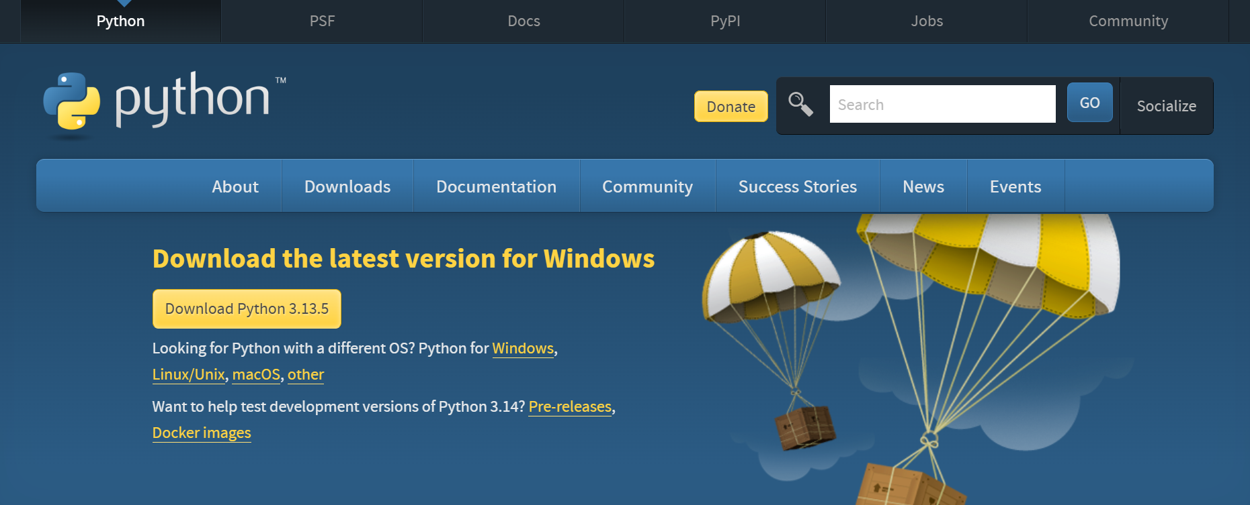

- Install Integrated development environment (IDE). We use Visual studio code that is free and open-source editor developed by Microsoft. It is designed to provide a streamlined and efficient coding experience for developers working on various platforms, including Windows, macOS, and Linux
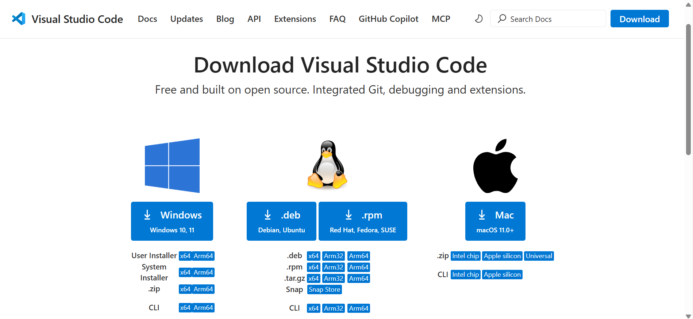

2. Features of Python
Python boasts a rich set of features that contribute to its popularity and versatility:
- Easy to Learn and Use: Python has a simple syntax that resembles the English language, making it accessible to beginners.
- Interpreted Language: Python code is executed line by line by an interpreter, which allows for faster debugging and development cycles compared to compiled languages.
- High-Level Language: It abstracts away complex details like memory management, allowing developers to focus on problem-solving.
- Object-Oriented: Python supports object-oriented programming (OOP) paradigms, encapsulating code within objects for modular and reusable design.
- Portable/Cross-Platform: Python programs can run on various platforms (Windows, macOS, Linux, etc.) without modification.
- Extensible: Python can be extended by integrating code written in other languages like C or C++.

3. Python Syntax
Python's syntax is designed for readability and simplicity. Unlike many other programming languages, Python uses indentation to define blocks of code (like the body of a loop, function, or conditional statement) instead of braces {}.
x = "Hello" # String
print(x)
y = 25 # Integer
print(y)
z = True # Boolean
print(z)

4. Comments
Comments are essential for making code understandable. Python supports single-line and multi-line comments.
4.1. Single-Line Comments
Single-line comments start with a hash symbol (#).
# This is a single-line comment
x = 10 # This comment explains the variable x
4.2. Multi-Line Comments
Python doesn't have a specific syntax for multi-line comments. Instead, you can use multi-line strings (triple quotes) that are not assigned to a variable; the interpreter will ignore them.
"""
This is a
multi-line
comment
"""
'''
This is also a
multi-line comment
'''
5. Variables
Variables are used to store data values. In Python, variables are created the moment you assign a value to them. You do not need to declare their data type explicitly; Python automatically infers the type based on the assigned value. Variables are case-sensitive (e.g., a and A are different).
x = 4 # x is an integer
x = "Hello" # x is now a string
print(x)
5.1. Variable Naming Rules
- Must start with a letter (A-z, a-z) or an underscore (_).
- Cannot start with a number.
- Can only contain alphanumeric characters (A-z, 0-9) and underscores.
- Variable names are case-sensitive.
- No spaces are allowed in the name.
Common Naming Conventions:
- Camel Case: myVariableName (first word lowercase, subsequent words start with uppercase)
- Pascal Case: MyVariableName (each word starts with uppercase)
- Snake Case: my_variable_name (words separated by underscores)

5.2. Assigning Multiple Values
You can assign multiple values to multiple variables in a single line, or one value to multiple variables.
# Multiple values to multiple variables
x, y, z = 24, 45, 67
print(x)
print(y)
print(z)
# One value to multiple variables
a = b = c = "Single"
print(a)
print(b)
print(c)

5.3. Global and Local Variables
Variables created inside a function are local and can only be used within that function. Variables created outside a function are global and can be accessed anywhere.
# Local variable
def func_local():
x_local = "local scope"
print(x_local)
func_local()
# print(x_local) # This would raise an error
# Global variable
x_global = "Global scope"
def func_global():
print(x_global)
func_global()
print(x_global)
# Using global keyword to modify a global variable from inside a function
def func_modify_global():
global x_global
x_global = "modified global"
print(x_global)
func_modify_global()
print(x_global)

6. Datatypes
Python has various built-in data types to categorize different kinds of values. Python does not have a separate character data type; a single character is simply a string of length 1.
- String (str)
- Integer (int)
- Float (float)
- Boolean (bool)
- List (list)
- Tuple (tuple)
- Dictionary (dict)
- Set (set)
- Range (range)

7. Operators
Operators are special symbols that perform operations on one or more operands.

7.1. Arithmetic Operators
Perform mathematical calculations.
- + (Addition)
- - (Subtraction)
- * (Multiplication)
- / (Division)
- % (Modulus – remainder)
- ** (Exponentiation)
- // (Floor Division – rounds the result down to the nearest whole number)
x = 10
y = 2
print(“Addition:”, x + y)
print(“Subtraction:”, x – y)
print(“Multiplication:”, x * y)
print(“Division:”, x / y)
print(“Modulus:”, x % y)
print(“Exponentiation:”, x ** y)
print(“Floor Division:”, x // y)

7.2. Assignment Operators
Used to assign values to variables.
- = (Assign)
- += (Add and assign)
- -= (Subtract and assign)
- *= (Multiply and assign)
- /= (Divide and assign)
- %= (Modulus and assign)
x = 10
print(x) # 5
x += 3 # x = x + 3 -> 8
print(x) # 8
x *= 3 # x = x * 3 -> 24
print(x) # 24

7.3. Comparison Operators
Compare two values and return True or False.
- == (Equal to)
- != (Not equal to)
- > (Greater than)
- < (Less than)
- >= (Greater than or equal to)
- <= (Less than or equal to)
x = 10
y = 2
print(x == y) # False
print(x != y) # True
print(x > y) # True
print(x < y) # False
print(x >= y) # True
print(x <= y) # False

7.4. Logical Operators
Combine conditional statements.
- and (Returns True if both statements are true)
- or (Returns True if at least one of the statements is true)
- not (Reverses the result, returns False if the result is true)
x = 4
y = 5
z = 6
print(x > y and y < z) # False and True -> False
print(x > y or y < z) # False or True -> True
print(not(x > y and y > z)) # not (False and False) -> not False -> True

7.5. Identity Operators
Compare the memory locations of two objects.
- is (Returns True if both variables are the same object)
- is not (Returns True if both variables are not the same object)
x = ["peach", "banana"]
y = ["peach", "banana"]
z = x
print(id(z))
print(id(x))
print(id(y))
print(x is z
print(x is y)
print(x == y)
7.6. Membership Operators
Test if a sequence (string, list, tuple, set, dictionary) contains a specific member.
- in (Returns True if a sequence with the specified value is present)
- not in (Returns True if a sequence with the specified value is not present)
x = ["peach", "banana"]
if "banana" in x:
print("Yes, 'banana' is in the list") # Yes
print("cherry" in x) # False
print("cherry" not in x) # True

8. Conditional Statements
Conditional statements allow your program to make decisions and execute different code blocks based on whether a condition is true or false.

8.1. if Statement
Executes a block of code only if the specified condition is true.
a = 15
b = 10
if (a > b):
print("a is greater than b") # This will not print as 10 is not greater than 20

8.2. if-else Statement
Executes one block of code if the condition is true, and another block if it's false.
age = 19
if (age <= 18):
print("Cannot vote")
else:
print("Can vote") # This will print

8.3. elif Statement
Used for multiple conditions. If the initial if condition is false, it checks the elif condition, and so on. An optional else can be at the end.
age = 18
if (age < 18):
print("Cannot vote")
elif (age > 18):
print("Can vote")
elif (age == 18):
print("Exactly 18 years old") # This will print
else:
print("Undefined age")

8.4. Nested if-else Statements
An if or if-else statement inside another if or else block.
Age = 20
citizen = True
if age >= 18:
if citizen:
print(“You are eligible to vote.”) # This will print
else:
print(“You must be a citizen to vote.”)
else:
print(“You are too young to vote.”)

8.5. The pass Statement
If an if statement (or any other block) is empty for some reason, you can use the pass statement to avoid an error. It does nothing.
a = 30
b = 10
if (a > b):
pass # No action needed, just pass

9. Loops
Loops are used to execute a block of code repeatedly. They help to adhere to the DRY (Don't Repeat Yourself) principle.

9.1. for Loop
Used for iterating over a sequence (like a list, tuple, dictionary, set, or string) or other iterable objects. It is typically used when you know the number of iterations in advance.
Using range()
The range() function generates a sequence of numbers. range(start_value, end_value-1)
# Loop from 0 to 5 (exclusive of 6)
for i in range(6):
print(i) # Output: 0, 1, 2, 3, 4, 5
# Loop from 1 to 5 (exclusive of 6)
for k in range(1, 6):
print(k) # Output: 1, 2, 3, 4, 5

9.2. while Loop
Executes a block of code as long as a specified condition is true. It is typically used when the number of iterations is not known beforehand.
i = 2
while (i < 6):
print(i)
i = i + 1
# Example: Print 2 table
i = 1
while (i <= 10):
print("2 *", i, "=", 2 * i)
i = i + 1

9.3. Nested Loops
A loop inside another loop. The inner loop executes completely for each iteration of the outer loop.
Adj = [“red”, “big”, “tasty”]
fruits = [“apple”, “banana”, “cherry”]
for x in adj:
for y in fruits:
print(x, y)

10. Control Statements
Control statements alter the flow of execution in loops.

10.1. break Statement
Terminates the loop entirely and transfers execution to the statement immediately following the loop.
i = 1
while i <= 10:
if i == 5:
break
print(i)
i = i + 1

10.2. continue Statement
Skips the rest of the current iteration of the loop and proceeds to the next iteration.
i = 0
while (i < 10):
i = i + 1
if (i == 5):
continue
print(i)

Chapter 2: Strings
Strings in Python are sequences of characters. They are immutable, meaning once created, their content cannot be changed. They are also an ordered/sequence type, allowing access to individual characters using indexing.

1. Creating Strings
Strings can be surrounded by either single quotes (') or double quotes (").
a = "hello"
print(a)
b = 'world'
print(b)

2. Indexing
Access individual characters using their index. Indexing starts from 0 for the first character.
a = "hello"
print(a[3]) # l
# Negative Indexing: Starts from the end, with -1 for the last character.
a = "hello"
print(a[-3]) # l

3. Length of a String
Use the len() function to get the number of characters in a string.
a = "hello" # Length is 5
print(len(a)) # 5

4. Looping Through a String
You can iterate over the characters of a string using a for loop.
print("With for loop")
a = "Mango"
for x in a:
print(x)
# Output:
# M
# a
# n
# g
# o
5. Check if Substring is Present
Use the in and not in keywords to check if a specific word or phrase is present in a string.
txt = "This is python code"
print("python" in txt) # True
print("java" in txt) # False
print("python" not in txt) # False

6. Slicing Strings
Slicing allows you to return a range of characters from a string. The syntax is [start:end], where end is exclusive.
a = "hello" # h=0, e=1, l=2, l=3, o=4
print(a[1:4]) # ell (characters from index 1 up to, but not including, 4)
a = "Hello! World"
print(a[3:8]) # lo! W
print(len(a)) # 12
print(a[6]) # W
print(type(a)) # <class 'str'>
print(a[:5]) # Hello (slice from start to index 4)
print(a[2:]) # llo! World (slice from index 2 to end)
# Slicing with Negative Indexing
a = "Hello! World" # H=-12, e=-11, ..., W=-5, o=-4, r=-3, l=-2, d=-1
print(a[-6:-1]) # World (from index -6 (W) up to, but not including, -1 (d))
Example:
my_string = "Python is very versatile!"
print("Original string:", my_string)
print("Length:", len(my_string))
# Slicing with positive indexing
print("Slice [0:6]:", my_string[0:6]) # Python
print("Slice [7:10]:", my_string[7:10]) # is
print("Slice [11:]: ", my_string[11:]) # very versatile!
# Slicing with negative indexing
print("Slice [-9:-1]:", my_string[-9:-1]) # ersatile
print("Slice [-10:]:", my_string[-10:]) # versatile!
7. Multiline Strings
You can create multiline strings using triple quotes ("""...""" or '''...''').
a = """hello
this
is
multiline string"""
print(a)

8. String Functions (Methods)
Python strings have many built-in methods to perform various operations.
- .upper(): Converts string to uppercase.
- .lower(): Converts string to lowercase.
- .replace(old, new): Replaces occurrences of a substring with another.
- .split(separator): Splits the string into a list of substrings based on a separator.
- .capitalize(): Converts the first character to uppercase and the rest to lowercase.
- .index(substring): Returns the lowest index where the substring is found. Raises an error if not found.
- .rindex(substring): Returns the highest index where the substring is found. Raises an error if not found.
- .find(substring): Similar to index(), but returns -1 if the substring is not found instead of raising an error.
- .rfind(substring): Similar to rindex(), but returns -1 if not found.
- .isalnum(): Returns True if all characters are alphanumeric (a-z, 0-9).
- .isalpha(): Returns True if all characters are alphabetic (a-z).
- .islower(): Returns True if all characters are lowercase.
- .isupper(): Returns True if all characters are uppercase.
- .isdigit(): Returns True if all characters are digits.
- .casefold(): Converts string to a casefolded string. Similar to lower() but handles more characters (e.g., German sharp s 'ß').

9. Escape Characters
Used to insert characters that are illegal in a string. An escape character is a backslash (\) followed by the character you want to insert.
- \": Double quote
- \': Single quote
- \n: Newline
- \t: Tab
- \b: Backspace
# Without escape character (will cause error):
# txt = "This is a string without "escape" characters."
txt = "This is a string with \"double quotes\"."
print(txt)
txt = "This is a string with \'single quotes\'."
print(txt)
txt = "This is a string with a \nnewline character."
print(txt)
txt = "This is a string with a \ttab character."
print(txt)
txt = "This is a string with a backspace\bcharacter." # Backspace removes the preceding character
print(txt)

Chapter 3: Lists and Tuple
Lists
Lists are used to store multiple items in a single variable. They are one of the four built-in data types in Python used to store collections of data (the others being Tuple, Set, and Dictionary). Lists are highly versatile due to their characteristics:
- Ordered: List items have a defined order, and that order will not change. New items are typically added to the end.
- Changeable/Mutable: You can change, add, and remove items after the list has been created.
- Allow Duplicate Values: Since lists are indexed, they can have items with the same value.
- Indexed: List items are indexed, starting from 0 for the first item, 1 for the second, and so on. Negative indexing starts from -1 for the last item.
- Defined by square brackets [].

list1 = ["peach", "banana", "cherry", "peach"]
print(list1) # ['mango', 'banana', 'cherry', 'mango']
print(len(list1)) # 4
xyz = [True, False, 56, "peach"]
print(xyz) # [True, False, 56, 'mango']
print(type(xyz)) # <class 'list'>

1. List Constructor list()
You can create a list using the list() constructor, often from an iterable like a tuple.
list3 = list(("peach", 30, "cherry", True, 55))
print(list3) # ['mango', 30, 'cherry', True, 55]

2. Accessing List Items
Access items by their index or a range of indexes.
2.1. Using Index
list4 = ["peach", 30, "cherry", True, 55]
print(list4[1]) # 30
# Negative indexing
print(list4[-2]) # True
2.2. Range of Indexes
Specify a start and end index (end is exclusive).
list5 = ["peach", 3.80, "cherry", True, 55, "banana", 5.7]
print(list5[2:6]) # ['cherry', True, 55, 'banana']
print(list5[:6]) # ['mango', 3.8, 'cherry', True, 55, 'banana'] (from start to index 5)
print(list5[2:]) # ['cherry', True, 55, 'banana', 5.7] (from index 2 to end)
# Range of negative indexes
print(list5[-5:-2]) # [True, 55, 'banana'] (from -5 (True) up to, but not including, -2 (5.7))

3. Check if Item Exists
Use the in keyword.
list6 = ["peach", 3.80, "cherry", True, 55, "banana", 5.7]
if 550 in list6:
print("yes")
else:
print("no") # no

4. Modifying List Items
Lists are mutable, so you can change item values or add/remove items.
4.1. Changing Item Value
my_list = ["guava", "pear", "plum"]
my_list[0] = "peach"
print(my_list) # ['mango', 'banana', 'cherry']
4.2. Adding Items: append(), insert(), extend()
- .append(item): Adds an item to the end of the list.
- .insert(index, item): Adds an item at a specified position.
- .extend(iterable): Appends elements from another list (or any iterable) to the current list.
4.3. Removing Items: remove(), pop(), del, clear()
- .remove(item): Removes the first occurrence of the specified item.
- .pop(index): Removes the item at the specified index. If no index is given, it removes and returns the last item.
- del keyword: Can remove an item at a specified index, or delete the entire list.
- .clear(): Empties the list. The list object remains, but it has no content.
5. Sorting Lists: sort()
Sorts the list alphanumerically, in ascending order by default. Use reverse=True for descending order.
list12 = ["peach", "cherry", "banana", "orange", "apple"]
list12.sort() # Sorts alphabetically
print(list12) # ['apple', 'banana', 'cherry', 'mango', 'orange']
list12.sort(reverse=True) # Sorts in descending order
print(list12) # ['orange', 'mango', 'cherry', 'banana', 'apple']

6. Looping Through a List
list13 = ["peach", "banana", "cherry"]
for x in list13:
print(x)
# Output:
# mango
# banana
# cherry

7. Copying a List: copy()
To avoid modifying the original list when working with a copy, use the .copy() method.
list15 = ["peach", "banana", "cherry", "orange", "apple"]
list16 = list15.copy()
print("list16 =", list16) # list16 = ['mango', 'banana', 'cherry', 'orange', 'apple']

Tuples
Tuples are used to store multiple items of different data types in a single variable. Tuples are Ordered and immutable. Indexed starting from 0. It allows duplicate values.
# Example of a tuple
xyz = ("item1", 34, True, 40.6, "item2")
print(xyz[4]) # Output: item2
print(xyz[1:4]) # Output: (34, True, 40.6)
tuple1=("Remote",True, 23, "Tv","Remote")
print(tuple1)
print(len(tuple1))

1. Type of tuple
tuple2=["Computer"]
print(type(tuple2)) # string.

tuple3=("Computer",)
print(type(tuple3)) # tuple.

2. Tuple constructor. tuple()
tuple4=tuple({"Pc", "laptop", 4})
print(tuple4)

3. Tuple Functions
count():- returns the no of times a specified value occurs in a tuple.
tuple8=(1,2,3,3,2,1,2,3,3,3,3,2,2)
x=tuple8.count(3)
print(x)

index():- search the tuple for a specified value and returns the position of where it was found.
tuple8=("apple",45,"cherry")
x=tuple8.index("cherry")
print(x)

del
tuple9=("apple","banana","cherry")
del tuple9
# # print(tuple9) # gives error.
print("The tuple is no longer exists")

Chapter 4: Set and Dictionaries
Set
It is used to store multiple items of different data types. It is written in {}.
Features
- Unordered i.e. it does not have defined order.
- Unindexed i.e. we cannot access items through index.
- Unchangeable i.e. we cannot change values once a set is created but we can add or remove.
- It does not allow duplicate values.
xyz={"Computer", 56, "PC", "Laptop", 5.2, True,"PC"}
print(xyz)

Functions on Set
add():
xyz={"Computer", 56, "PC", 56, "PC","Laptop", 52}
xyz.add("Mouse")
print("\n",xyz)

update():
set1={"Computer", 56, "PC","Laptop", 52}
set2={"Keyboard", 456}
set1.update(set2)
print(set1)

remove(): remove specific value and if the item/value not found then it will give error.
set1={"Computer", 56, "PC","Laptop", 52}
set1.remove(56)
print(set1)

discard(): remove specific value and if the item not found then it will not give error.
set1={"Computer", 56, "PC","Laptop", 52}
set1.discard("PC")
print(set1)

del(): will delete the whole set.
set={1,3,6,7,5.6,"Hello"}
del set
print(set)
print("This set is no longer exists.")

union(): return new set which contains both set value.
set1={"Computer", 56, "PC","Laptop", 52}
set2={"Keyboard", 456,"Hello"}
set=set1.union(set2)
print(set)

intersection(): return new set with common values.
set1={"Computer", 56, "PC","Laptop", 52}
set2={"Keyboard","PC", 456,"Hello"}
set=set1.intersection(set2)
print(set)

Dictionaries
Dictionaries are enclosed in {} and have keys and values. It is used to store multiple items of different datatype in a single variable. It is ordered and changeable. Dictionaries do not allow duplicate values.
# Example of a dictionary
xyz = {
"name": "ABC",
"Course": "Python",
"Timings": 10.30
}
xyz["Course"] = "JavaScript" # Updates value
xyz["state"] = "Punjab" # Adds a new key-value pair
print(xyz)
Loop through dictionary
xyz={
"name":"ABC",
"Course":"Python",
"Timings":10.30,
"Colors":{"color1":"red","color2":"blue","color3":"pink"}
}
for i in xyz:
print(xyz[i]) # xyz[Course] will print values.

for i in xyz:
print(i) # will print keys.

Dictionary Functions
update(): add new key or update existing one.
pop(): removeitem with specific key.
Popitem(): remove last item.
clear() to clear dict items.
del remove item with specific key. can delete the dict.

Chapter 5: Functions and Modules
Functions
Functions are blocks of reusable code. They help in organizing code and making it modular.
# Defining and calling a function
def greet(name):
print(f"Hello, {name}!")
greet("Alice")
Lambda Functions
Lambda functions, also known as anonymous functions, are small functions defined with the lambda keyword. They can take any number of arguments but can only have one expression.
# Example of a lambda function
add_ten = lambda x: x + 10
print(add_ten(5)) # Output: 15
multiply = lambda x, y: x * y
print(multiply(5, 6)) # Output: 30
Lambda functions are often used where a small function is required for a short period, such as in arguments to higher-order functions (like `map`, `filter`, `sorted`).
Modules
A module is simply a Python file (.py) containing Python definitions and statements. Packages are collections of modules organized in directories.
Modules allow you to logically organize your Python code. You can import modules to use their functions and variables.
Math module
import math
print(math.sqrt(64)) # Output: 8.0
print(math.pi) # Output: 3.141592653589793
y=math.floor(88.78) # rounds a number downwards to its nearest integer.
print(y)

x=math.ceil(88.78) # rounds a number upwards to its nearest integer. 1.1,1.2,...1.9=2
print(x)

x=math.pi # returns pi value
print(x)

x=math.e # returns euler's number
print(x)

Datetime Module
from datetime import datetime
now = datetime.now()
print(f"Current date and time: {now}")
print(f"Current year: {now.year}")

Chapter 6: Object-Oriented Programming (OOP) in Python
Python supports OOP principles, allowing you to create programs using objects that have attributes (data) and methods (functions).
1. Classes and Objects
A class is a blueprint for creating objects. An object is an instance of a class.

2. Constructor (`__init__`)
The __init__ method is a special method that acts as a constructor. It's automatically called when an object of a class is created.
class Dog:
def __init__(self, name, breed):
self.name = name # Attribute
self.breed = breed # Attribute
def bark(self): # Method
print(f"{self.name} says Woof!")
my_dog = Dog("Buddy", "Golden Retriever")
print(f"My dog is a {my_dog.breed}")
my_dog.bark()
3. Inheritance
Inheritance allows a class (child class) to inherit attributes and methods from another class (parent class). This promotes code reusability.
Single Inheritance
class Animal:
def eat(self):
print("This animal eats food.")
class Cat(Animal):
def meow(self):
print("Meow!")
my_cat = Cat()
my_cat.eat()
my_cat.meow()
Multiple Inheritance
A class can inherit from multiple parent classes.
print("Multiple Inheritance")
class Parent1: # Parent1/Base1/Super1
height="160"
hair="Black"

class Parent2: # Parent2/Base2/Super2
color="brown"
eyes="small"

class Child(Parent1,Parent2): # Child
age="15"

obj=Child()
print(obj.height)
print(obj.color + " " + obj.eyes)

Multilevel Inheritance
A class inherits from a class, which in turn inherits from another class.
print("Multilevel Inheritance")
class GrandParents:
hair="black"
weight="65"

class Parents(GrandParents):
color="brown"
eyes="small"

class Child(Parents):
age=10

obj1=Parents()
obj2=Child()
print(obj1.hair)
print(obj1.color)
# print(obj1.age) # Cannot access

Abstraction
Abstraction involves hiding complex implementation details and showing only essential features. In Python, this is often achieved using abstract base classes (ABCs) and the abc module.
from abc import ABC, abstractmethod
class Shape(ABC):
@abstractmethod
def area(self):
pass
class Circle(Shape):
def __init__(self, radius):
self.radius = radius
def area(self):
return 3.14 * self.radius * self.radius
my_circle = Circle(5)
print(f"Area of the circle: {my_circle.area()}")
Encapsulation
Encapsulation is the bundling of data (attributes) and methods that operate on the data within a single unit (class). It restricts direct access to some of the object's components, often using private attributes (prefixed with double underscores `__`).
class Car:
def __init__(self, make, model):
self.make = make
self.__model = model # Private attribute
def get_model(self): # Getter method
return self.__model
my_car = Car("Toyota", "Camry")
print(my_car.make)
print(my_car.get_model())
# print(my_car.__model) # This would raise an AttributeError

Chapter 7 : Machine Learning - Supervised and Unsupervised Learning

Introduction
Machine Learning is a branch of artificial intelligence that focuses on developing algorithms capable of learning patterns from data. These algorithms improve performance by identifying relationships, trends, and structures without being explicitly programmed for each task.
Machine learning techniques are broadly categorized into:
• Supervised Learning
• Unsupervised Learning

1. Supervised Learning

Definition
Supervised learning is a machine learning paradigm in which a model is trained using labeled data. Each training example contains both input features and the corresponding target output.
Objective:
Learn a mapping between input variables and known outputs.

Key Characteristics
• Requires labeled datasets
• Used for prediction tasks
• Includes classification and regression problems

Types of Supervised Learning

1. Linear Regression
Purpose: Predict continuous numerical values.
Concept:
Models a linear relationship between independent variables and a dependent variable.
Typical Use Cases:
• Price prediction
• Trend estimation
• Forecasting

2. Logistic Regression
Purpose: Classification tasks.
Concept:
Estimates probability of class membership using a logistic function.
Typical Use Cases:
• Binary classification
• Risk prediction
• Decision systems

3. Decision Tree
Purpose: Classification and regression.
Concept:
Splits data based on feature thresholds forming a tree-like structure.
Key Properties:
• Easy interpretability
• Susceptible to overfitting

4. Support Vector Machine (SVM)
Purpose: Classification and regression.
Concept:
Identifies an optimal hyperplane separating classes.
Key Properties:
• Effective in high-dimensional spaces
• Computationally intensive for large datasets

5. k-Nearest Neighbors (k-NN)
Purpose: Classification and regression.
Concept:
Predictions based on similarity with nearest data points.
Key Properties:
• No explicit training phase
• Sensitive to feature scaling

6. Random Forest (Major Model)

Definition
Random Forest is an ensemble supervised learning algorithm that constructs multiple decision trees during training and aggregates their outputs to produce final predictions.

Core Principle
Instead of relying on a single decision tree, Random Forest combines predictions from numerous trees to improve accuracy and stability.

Working Mechanism
Random Forest operates through:

1. Bootstrap Sampling
Each tree is trained on a randomly selected subset of the dataset.
Effect:
• Introduces diversity
• Reduces model variance

2. Random Feature Selection
Each split considers a random subset of features.
Effect:
• Prevents dominance of specific features
• Enhances generalization

3. Ensemble Aggregation
Final prediction is determined by:
• Majority voting (classification)
• Averaging (regression)

Advantages
• Reduces overfitting compared to decision trees
• Handles nonlinear relationships effectively
• Works with large datasets
• Robust to noise
• Less sensitive to feature scaling

Suitability for Weather Prediction
Weather systems involve complex interactions between atmospheric variables.
Random Forest effectively models:
• Nonlinear dependencies
• Feature interactions
• High-dimensional inputs

Limitations
• Reduced interpretability compared to single trees
• Higher computational cost
• Larger memory usage

2. Unsupervised Learning

Definition
Unsupervised learning involves training models using unlabeled data. The objective is to identify hidden structures, patterns, or groupings within the dataset.

Key Characteristics
• No target variable
• Pattern discovery
• Clustering and dimensionality reduction

Types of Unsupervised Learning

1. k-Means Clustering
Purpose: Group similar data points.
Concept:
Partitions data into k clusters based on similarity.

2. Hierarchical Clustering
Purpose: Build cluster hierarchies.
Concept:
Creates tree-like cluster structures.

3. Principal Component Analysis (PCA)
Purpose: Dimensionality reduction.
Concept:
Transforms features into principal components.

4. Association Rule Learning
Purpose: Discover relationships.
Concept:
Identifies frequent patterns (e.g., market basket analysis).

Comparison: Supervised vs Unsupervised Learning
Aspect | Supervised Learning | Unsupervised Learning
Data Type | Labeled Data | Unlabeled Data
Objective | Prediction | Pattern Discovery
Output | Known Target | Hidden Structure
Tasks | Classification / Regression | Clustering / Reduction

Conclusion
Machine learning techniques provide computational methods for analyzing complex datasets. Supervised learning focuses on prediction using labeled data, while unsupervised learning emphasizes structure discovery.

FastAPI Overview

1. Introduction
FastAPI is a modern Python web framework designed for developing high-performance APIs. It emphasizes speed, reliability, and ease of development through automatic data validation and documentation generation. The framework is widely adopted in backend systems, microservices architectures, and machine learning model deployment environments.
FastAPI is categorized as an ASGI-based framework, enabling asynchronous request processing and efficient handling of concurrent operations. Its design integrates Python’s type hinting system to enforce validation rules and ensure structured communication between clients and servers.

2. Definition
FastAPI is a Python web framework used for building Application Programming Interfaces (APIs). It leverages Python type hints, asynchronous execution models, and automatic validation mechanisms to provide a structured and efficient API development environment.

3. Architectural Foundations
FastAPI is built upon two major underlying technologies:
Starlette → ASGI toolkit responsible for web handling
Pydantic → Data validation and parsing framework
This layered architecture separates concerns:
• Request/Response handling → Starlette
• Data validation & serialization → Pydantic

4. ASGI (Asynchronous Server Gateway Interface)
ASGI represents the next-generation interface for Python web applications, designed to replace WSGI (Web Server Gateway Interface).

Key Properties of ASGI
• Supports asynchronous execution
• Enables concurrent request handling
• Optimized for I/O-bound workloads
• Compatible with modern networking protocols
Unlike WSGI, which processes requests sequentially, ASGI allows multiple requests to be handled simultaneously.

5. Performance Characteristics
FastAPI’s performance efficiency arises from:
• Asynchronous request handling
• Lightweight framework design
• Efficient data parsing mechanisms
• Minimal overhead architecture
Observed industry patterns indicate improved throughput for applications involving:
• Database queries
• Network communication
• External API calls
• File operations

6. Routing Mechanism
FastAPI defines application behavior through routes.

Definition of Routes
A route represents a mapping between:
• URL path
• HTTP method
• Handler function
Example structure:
@app.get("/resource/")
def handler():
return {"message": "Response"}

7. HTTP Method Handling
FastAPI supports standard HTTP operations:
GET → Data retrieval
POST → Data creation
PUT → Data update
DELETE → Data removal
Each method reflects RESTful communication principles.

8. Request Processing Lifecycle
A FastAPI request follows a structured lifecycle:
- Client sends HTTP request
- ASGI server receives request
- FastAPI route resolution
- Data validation (Pydantic)
- Business logic execution
- Response serialization
- Response returned to client

9. Path Parameters
Path parameters enable dynamic URL structures.
Example:
@app.get("/items/{item_id}")
def read_item(item_id: int):
return {"item_id": item_id}

Validation Behavior
FastAPI automatically enforces:
• Data types
• Required parameters
• Constraint violations

10. Query Parameters
Query parameters represent optional inputs.
Example:
@app.get("/search/")
def search(q: str = None):
return {"query": q}

11. Request Body Validation
FastAPI commonly uses Pydantic models.
Example:
class Data(BaseModel):
value: float

Validation Mechanism
Pydantic performs:
• Type enforcement
• Structural validation
• Constraint checking
• Error reporting
Invalid inputs trigger automatic error responses.

12. Pydantic Data Model Role
Pydantic enables:
• Data parsing
• Type conversion
• Validation
• Serialization
Example constraints:
• Minimum/maximum values
• String length
• Optional fields

13. Response Serialization
FastAPI automatically converts Python objects into:
• JSON responses
• Structured API outputs
Benefits:
• Consistent client communication
• Reduced manual formatting

14. Dependency Injection System
FastAPI includes a built-in dependency resolution mechanism.

Purpose of Dependencies
• Reusable logic
• Authentication
• Database sessions
• Configuration management
Example:
def dependency():
return "value"

Operational Benefit
• Separation of concerns
• Code modularity
• Reduced redundancy

15. Middleware Architecture
Middleware components intercept requests globally.

Typical Middleware Functions
• Logging
• Security checks
• Request modification
• Performance monitoring
Middleware executes before route handlers.

16. Exception Handling
FastAPI provides structured error management.
Example:
raise HTTPException(status_code=404)

Advantages
• Standardized error responses
• Predictable client behavior

17. Asynchronous Execution Model
FastAPI supports:
Synchronous Functions
Asynchronous Functions
Example:
async def handler():

Advantages of Async Execution
• Efficient I/O operations
• Reduced blocking
• Improved scalability

18. Concurrency and Scalability
Concurrency improves:
• Throughput
• Resource utilization
• Response times under load
FastAPI is particularly effective in:
• Microservices
• Data-intensive APIs
• ML inference endpoints

19. Automatic API Documentation
FastAPI automatically generates:
Swagger UI → /docs
ReDoc → /redoc

Functional Advantages
• Interactive testing
• Schema visualization
• Reduced documentation overhead

20. Security Mechanisms
FastAPI supports modern security protocols:
• OAuth2
• JWT Authentication
• API Key Validation

Security Objectives
• User authentication
• Access control
• Endpoint protection

21. CORS Handling
Cross-Origin Resource Sharing (CORS) enables:
• Frontend-backend integration
• Cross-domain communication

22. Database Integration
FastAPI integrates with databases through:
• ORM frameworks
• Async database drivers
• Connection pooling
Typical flow:
Request → Query → Response

23. Background Task Processing
Background tasks execute after response delivery.
Common applications:
• Logging
• Notifications
• Data processing

24. Testing Capabilities
FastAPI includes utilities for:
• Unit testing
• Endpoint validation
• Automated testing workflows

25. Deployment Architecture
FastAPI applications are deployed using:
• Uvicorn
• Gunicorn with Uvicorn workers
• Containerized environments

26. Advantages of FastAPI
• High performance
• Automatic validation
• Automatic documentation
• Strong typing integration
• Asynchronous execution support
• Minimal boilerplate code

27. Limitations
• Requires understanding of async programming
• Less suited for traditional templated web pages
• Increased complexity in large dependency graphs

28. Comparison with Traditional Frameworks
Aspect | FastAPI | Flask | Django
Performance | High (ASGI) | Moderate | Moderate
Validation | Automatic | Manual | Manual
Documentation | Automatic | Manual | Manual
Async Support | Native | Limited | Partial

29. Role in Machine Learning Deployment
FastAPI is widely used for:
• Model inference APIs
• Prediction services
• Data processing endpoints
Advantages:
• Low latency responses
• Efficient request handling
• Structured validation

30. Conceptual Summary
FastAPI integrates:
• Performance optimization
• Validation automation
• Developer productivity
Its architecture supports modern backend system requirements, particularly in data-driven and microservices environments.

Conclusion
FastAPI provides a structured framework for high-performance API development. Its combination of asynchronous execution, automatic validation, and documentation generation enables efficient backend system design. The framework is particularly suitable for scalable services, including machine learning model deployment and data processing applications.

Chapter 9 : Weather Prediction System Using Random Forest and FastAPI

1. Introduction
Weather prediction is a computational problem involving the analysis of atmospheric variables to estimate future conditions. Traditional forecasting methods rely on physical simulations; however, machine learning techniques provide data-driven alternatives capable of modeling complex relationships between meteorological attributes.
This project presents the design and implementation of a machine learning-based weather prediction system. The system utilizes a Random Forest algorithm for predictive modeling and FastAPI as the deployment framework. Model persistence is achieved through Pickle serialization, enabling efficient storage and reuse of the trained model.
The implemented solution demonstrates the integration of data preprocessing, machine learning model development, model serialization, and API-based deployment.

2. Objectives of the Project
The primary objectives of the system include:
• To analyze historical weather data
• To develop a predictive machine learning model
• To implement Random Forest for weather prediction
• To serialize the trained model using Pickle
• To deploy the model using FastAPI
• To enable external interaction through API endpoints

3. Dataset Description and Data Characteristics

1. Introduction
The performance and reliability of a machine learning system are fundamentally dependent on the quality and structure of the dataset used for model training. In the present project, a historical weather dataset was utilized to develop the predictive model. The dataset contains structured meteorological observations recorded across multiple years.
Although the dataset does not include an explicit textual description, the available attributes provide sufficient information regarding atmospheric conditions, environmental measurements, and weather-related variables. The dataset represents real-world environmental data characterized by variability, seasonal fluctuations, and nonlinear relationships among features.

2. Type of Dataset
The dataset employed in this project can be categorized as:
Structured Dataset
Multivariate Dataset
Time-Series Dataset
Mixed Data-Type Dataset

2.1 Structured Dataset
The dataset follows a tabular format consisting of rows and columns. Each row represents an individual weather observation, while each column corresponds to a specific meteorological attribute.
Characteristics:
• Clearly defined feature variables
• Consistent record format
• Suitable for supervised learning models

2.2 Multivariate Dataset
The dataset contains multiple independent variables describing atmospheric conditions.
Examples of variables include:
• Temperature
• Humidity
• Wind Speed
• Visibility
• Cloud Cover
This multivariate nature allows the model to learn complex relationships between interacting features.

2.3 Time-Series Dataset
The presence of a Formatted Date attribute indicates temporal ordering of observations.
Observed characteristics:
• Data spans multiple years
• Sequential environmental measurements
• Captures seasonal variations
Time-dependent datasets are particularly valuable in forecasting and prediction tasks.

2.4 Mixed Data-Type Dataset
The dataset includes both:
Numerical Variables
Categorical Variables

3. Dataset Attributes
The dataset consists of the following features:
• Formatted Date → Timestamp of observation
• Summary → General weather condition
• Precipitation Type → Rain, Snow, etc.
• Temperature (C) → Measured temperature
• Apparent Temperature (C) → Perceived temperature
• Humidity → Atmospheric moisture level
• Wind Speed (km/h) → Wind velocity
• Wind Bearing (degrees) → Wind direction
• Visibility (km) → Atmospheric clarity
• Cloud Cover → Sky condition indicator

4. Numerical Features
Numerical features represent continuous environmental measurements.

4.1 Temperature Variables
Observed temperature values range approximately between:
Minimum → -21.8°C
Maximum → 39.9°C
This wide range indicates:
• Seasonal variation
• Diverse climatic conditions
• Suitability for predictive modeling

4.2 Apparent Temperature
Apparent Temperature reflects perceived temperature influenced by humidity and wind.
Observed characteristics:
• Closely correlated with temperature
• Provides enhanced predictive context

4.3 Humidity
Humidity values range from:
0 → 1
Characteristics:
• Normalized representation
• Continuous atmospheric measurement

4.4 Wind Speed
Wind Speed values range between:
0 → 63.9 km/h
Characteristics:
• Represents kinetic atmospheric activity
• Exhibits variability across records

4.5 Wind Bearing
Wind Bearing spans:
0° → 359°
Characteristics:
• Circular directional variable
• Represents wind direction

4.6 Visibility
Visibility measurements represent atmospheric clarity.
Characteristics:
• Sensitive to fog, rain, and cloud cover
• Important for weather classification

4.7 Cloud Cover
Cloud Cover indicates sky conditions.
Characteristics:
• Influences temperature perception
• Impacts visibility and precipitation

5. Categorical Features
Categorical features describe qualitative weather conditions.

5.1 Summary Attribute
Weather summaries include categories such as:
• Partly Cloudy → 33%
• Mostly Cloudy → 29%
• Other → 38%
Characteristics:
• Represents overall atmospheric state
• Requires encoding for ML usage

5.2 Precipitation Type
Distribution observed:
• Rain → 88%
• Snow → 11%
• Other → 1%
Characteristics:
• Indicates weather events
• Contributes to classification tasks

6. Temporal Coverage
The dataset spans multiple observation periods:
2005 – 2016
Characteristics:
• Multi-year environmental data
• Captures climatic variability
• Enables generalized model training
Consistent record counts across intervals suggest structured sampling.

7. Data Distribution Characteristics
The dataset exhibits realistic environmental variability.
Observed patterns:
• Temperature clustering in moderate ranges
• Sparse representation at extremes
• Humidity concentration in higher intervals
• Wind speed dominance in mid-ranges
Such distributions are typical of atmospheric datasets.

8. Dataset Relevance to the Project
The dataset is appropriate for weather prediction due to:
• Multivariate feature representation
• Continuous environmental measurements
• Temporal structure
• Mixed data types
• Real-world variability
These characteristics enable effective learning of atmospheric patterns by the Random Forest model.

9. Dataset Challenges
Environmental datasets typically present challenges:
• Noise in measurements
• Nonlinear feature relationships
• Seasonal variability
• Imbalanced categorical distributions
Random Forest models are well-suited to address such complexities.

10. Conceptual Summary
✔ Data Preprocessing (Very Detailed)
✔ Feature Engineering Section
✔ Exploratory Data Analysis (EDA)
✔ Model Training Methodology
✔ Evaluation & Metrics Section
✔ System Architecture Chapter

4. Data Preprocessing
Preprocessing ensures dataset consistency and model reliability.

4.1 Handling Missing Values
Incomplete records may affect model performance. Standard techniques include:
• Removal of invalid entries
• Imputation of missing values
• Feature-specific corrections

4.2 Feature Encoding
Categorical attributes such as:
• Summary
• Precipitation Type
require transformation into numerical representations.
Common techniques:
• Label Encoding
• One-Hot Encoding

4.3 Feature Selection
Relevant predictive variables include:
• Temperature
• Apparent Temperature
• Humidity
• Wind Speed
• Wind Bearing
• Visibility
• Cloud Cover

4.4 Normalization
Normalization improves numerical stability.
Methods:
• Min-Max Scaling
• Standardization

5. Machine Learning Model Selection

5.1 Random Forest Algorithm
Random Forest is an ensemble supervised learning algorithm based on decision trees.

Operational Principle
• Multiple decision trees are constructed
• Each tree is trained on random data subsets
• Predictions are aggregated

5.2 Justification for Model Selection
Random Forest was selected due to:
• Ability to model nonlinear relationships
• Resistance to overfitting
• Robustness to noise
• Effective handling of high-dimensional data
Weather data typically exhibits complex dependencies between variables, making Random Forest suitable for predictive modeling.

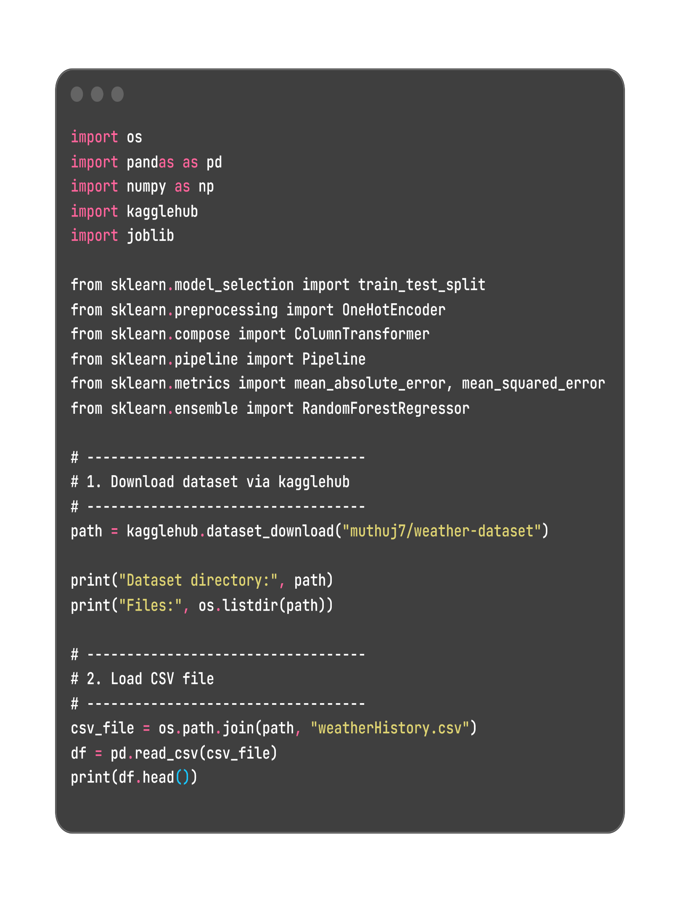

6. Model Training Process

6.1 Dataset Splitting
The dataset is divided into:
• Training Set
• Testing Set
Purpose:
Evaluate model generalization.

6.2 Model Learning
During training:
• Trees are constructed
• Feature splits are evaluated
• Decision boundaries are learned

6.3 Prediction Mechanism
Final outputs are obtained via:
• Majority voting (classification)
• Averaging (regression)

7. Model Persistence Using Pickle

7.1 Need for Model Serialization
Machine learning models are computationally expensive to train. Re-training for every execution is inefficient.
Serialization enables:
• Permanent model storage
• Reusability
• Faster deployment

7.2 Pickle Overview
Pickle is a Python module used for object serialization.

Key Capabilities
• Converts Python objects into byte streams
• Stores models on disk
• Restores objects later

7.3 Creating the Pickle File
After model training:
import pickle

with open("model.pkl", "wb") as file:
pickle.dump(model, file)

Explanation
• pickle.dump() → Serializes model
• "wb" → Write binary mode
• Output → Persistent model file

7.4 Advantages of Pickle Serialization
• Eliminates repeated training
• Reduces computational overhead
• Enables production deployment

8. FastAPI Integration

8.1 Purpose of FastAPI
FastAPI serves as the deployment framework, enabling:
• API-based access to predictions
• Structured request handling
• Scalable backend architecture

8.2 Loading the Pickled Model
FastAPI loads the serialized model:
import pickle

with open("model.pkl", "rb") as file:
model = pickle.load(file)

Explanation
• pickle.load() → Restores model
• "rb" → Read binary mode

8.3 API Endpoint Design
FastAPI exposes prediction functionality:
@app.post("/predict/")
def predict(data: InputData):
prediction = model.predict([data.features])
return {"prediction": prediction.tolist()}

8.4 Request Handling Workflow
- Client sends request
- FastAPI receives input
- Data validation occurs
- Model processes features
- Prediction returned

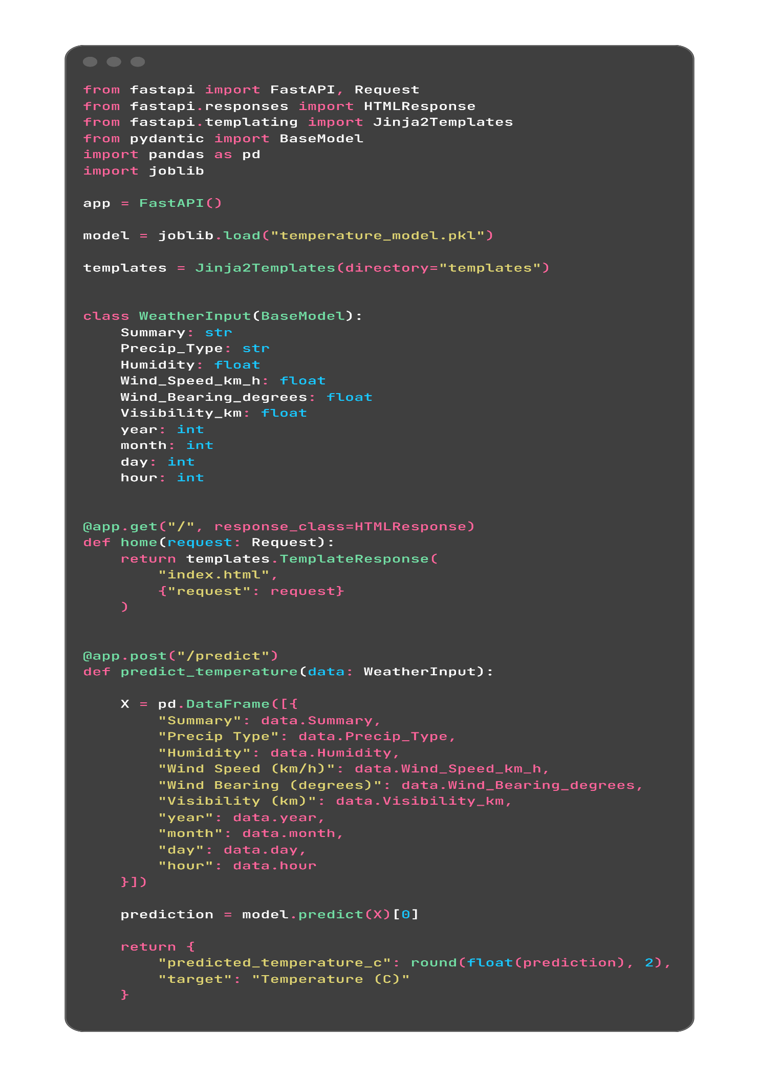

9. System Workflow

Step 1: Data Input
User provides meteorological parameters.

Step 2: API Processing
FastAPI validates request structure.

Step 3: Model Inference
Serialized Random Forest model generates prediction.

Step 4: Response Generation
Prediction returned as JSON response.

10. Advantages of the Implemented System

10.1 Computational Efficiency
• Model trained once
• Pickle avoids retraining

10.2 Scalability
• FastAPI supports concurrent requests
• Suitable for production environments

10.3 Reliability
• Automatic validation
• Structured error handling

10.4 Flexibility
• Model can be replaced without redesigning API

11. Practical Significance
The system demonstrates:
• End-to-end ML deployment pipeline
• Model persistence strategy
• API-driven prediction architecture
This workflow mirrors common industry practices in ML engineering.

12. Limitations

• Accuracy dependent on dataset quality
• Environmental variability introduces uncertainty
• Ensemble models require higher memory

13. Conclusion
This project illustrates the development of a weather prediction system integrating machine learning and modern API frameworks. Random Forest provides robust predictive capabilities, while Pickle serialization ensures efficient model reuse. FastAPI enables scalable and structured deployment.
The system highlights the practical application of machine learning models in real-world deployment scenarios.

14. Future Scope

• Integration with real-time data sources
• Advanced hyperparameter tuning
• Deployment monitoring mechanisms
• Visualization dashboards

